**NCADB**

**Summer Event**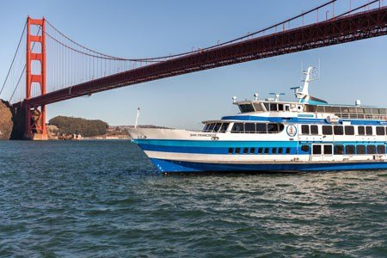

**Angel Island**

**Saturday, August 10, 2024**

**Admission Fee: $35 each person**

**Lunch is included (Chicken or veggie wraps, potato salad, fruit salad, cookies, and water bottle)**

**RSVP is no later than Friday, July 26th. We accept a check, money order, Venmo and Zelle. Any question, please email to NCADBinfo@gmail.com**

**Meet at**

**The San Francisco Ferry Building**

**Pier 1**

**1 Ferry Building**

**San Francisco, CA 94111**

**Time: 10:30am (Ferry will depart at 11am)**

**We will ride on the Golden Gate Ferry to the Island.**

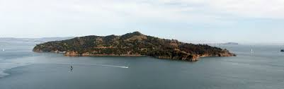**Activities at the island**

* **Hiking**
* **Tram Tours**
* **Biking**
* **Picnic**
* **Relaxing**

**How to get there:**

**Embarcadero BART**

**Located in San Francisco's Financial District at the foot of Market Street, Embarcadero Station is close to the Ferry Building, Embarcadero Center, Salesforce Transit Center, and the California Street cable car.**

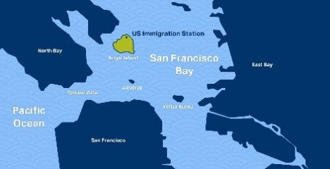**After Angel Island, you can explore the shops,   
restaurants, and Farmer’s market at the San Francisco Ferry Marketplace building.**